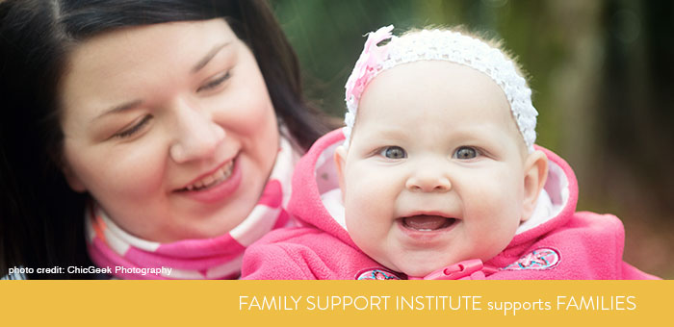  October 17, 2019  Do You have a Family Member With A Disability?  COME MEET OUR FRASER SOUTH REGIONAL NETWORK COORDINATOR, KAREN AND LEARN MORE ABOUT FSI!  The Family Support Institute (FSI) has volunteer Resource Parents (RP’s) who will support you by:  - Providing emotional support  - Guiding you to community resources  - Attending meetings with you; taking notes; sharing information afterwards  - Mentoring and coaching on advocacy for you and your family member  - Providing education and workshops  - Sharing successes, celebrating families and more!  Come learn more about FSI’s family to family caregiver support, tools and resources for families or even how to become a Resource Parent yourself!  MY Booklet BC, Find Support BC, Transition Timeline are a few of the resources we will share with you and they are all FREE!  FAMILIES ARE THE BEST RESOURCE TO SUPPORT ONE ANOTHER. | Family Support Institute of BC (FSI) is a provincial not for profit society committed to supporting families who have a family member with a disability.  FSI is unique in Canada and the only grass roots family to family organization that has a broad volunteer base.  FSI supports and services are free to any family.  Family Support Institute of bC  www.familysupportbc.com  Thursday October 17  6:30 – 8:30 pm  Seaquam Secondary - Theatre 11584 Lyon Road - Delta

